**Exercise 1: Configuring a Basic Spring Application**

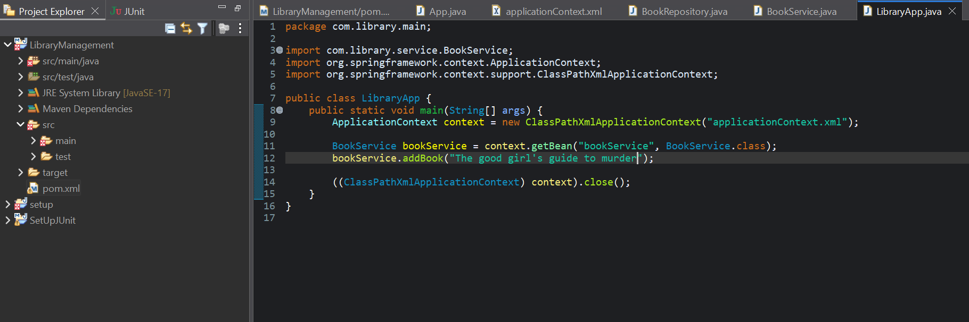

Output

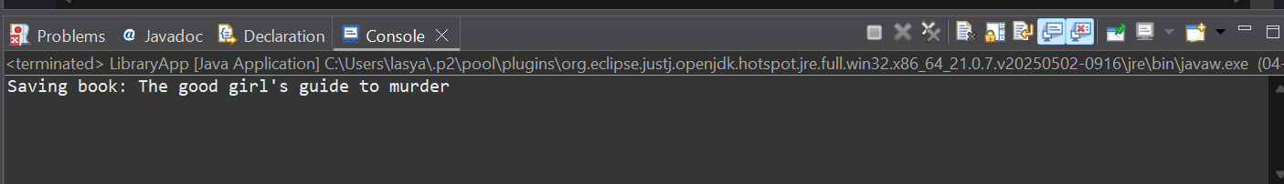

**Exercise 2: Implementing Dependency Injection**

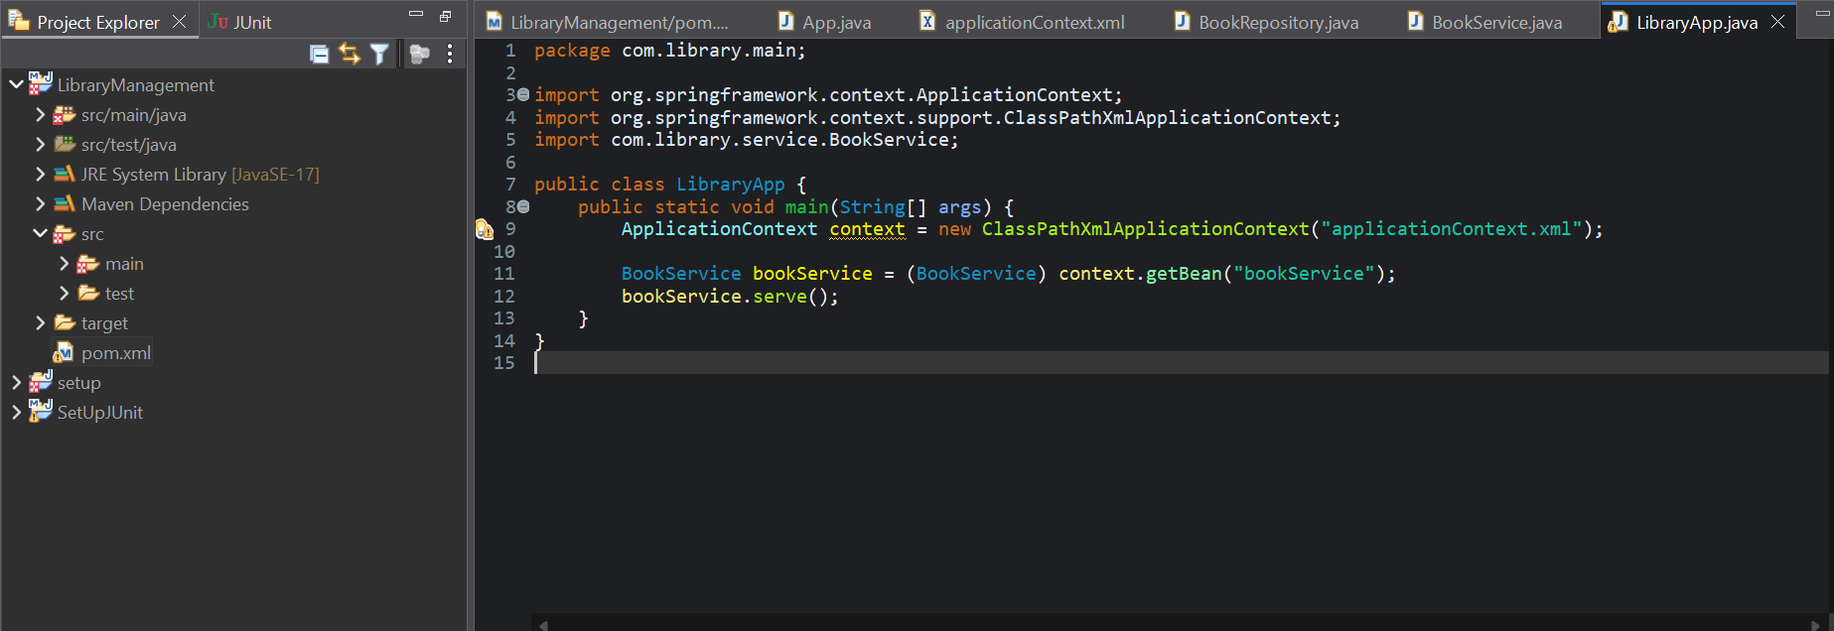

Output

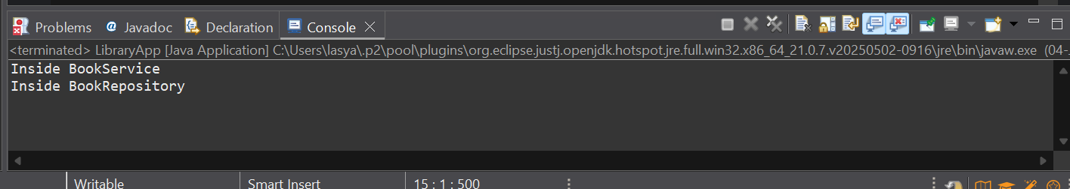

**Exercise 4: Creating and Configuring a Maven Project**

<project xmlns="http://maven.apache.org/POM/4.0.0"

xmlns:xsi="http://www.w3.org/2001/XMLSchema-instance"

xsi:schemaLocation="http://maven.apache.org/POM/4.0.0 https://maven.apache.org/xsd/maven-4.0.0.xsd">

<modelVersion>4.0.0</modelVersion>

<groupId>com.library</groupId>

<artifactId>LibraryManagement</artifactId>

<version>0.0.1-SNAPSHOT</version>

<name>LibraryManagement</name>

<url>http://www.example.com</url>

<properties>

<project.build.sourceEncoding>UTF-8</project.build.sourceEncoding>

<maven.compiler.source>17</maven.compiler.source>

<maven.compiler.target>17</maven.compiler.target>

</properties>

<dependencies>

<dependency>

<groupId>org.junit.jupiter</groupId>

<artifactId>junit-jupiter-api</artifactId>

<version>5.11.0</version>

<scope>test</scope>

</dependency>

<dependency>

<groupId>org.junit.jupiter</groupId>

<artifactId>junit-jupiter-params</artifactId>

<version>5.11.0</version>

<scope>test</scope>

</dependency>

<dependency>

<groupId>org.springframework</groupId>

<artifactId>spring-context</artifactId>

<version>5.3.33</version>

</dependency>

<dependency>

<groupId>org.springframework</groupId>

<artifactId>spring-core</artifactId>

<version>5.3.33</version>

</dependency>

<dependency>

<groupId>org.springframework</groupId>

<artifactId>spring-beans</artifactId>

<version>5.3.33</version>

</dependency>

<dependency>

<groupId>org.springframework</groupId>

<artifactId>spring-aop</artifactId>

<version>5.3.33</version>

</dependency>

<dependency>

<groupId>org.springframework</groupId>

<artifactId>spring-webmvc</artifactId>

<version>5.3.33</version>

</dependency>

</dependencies>

<build>

<plugins>

<plugin>

<groupId>org.apache.maven.plugins</groupId>

<artifactId>maven-compiler-plugin</artifactId>

<version>3.10.1</version>

<configuration>

<source>17</source>

<target>17</target>

</configuration>

</plugin>

</plugins>

</build>

</project>